**Task 1:**

Make a growth hacking plan for promotion of an On-Demand Cab Service PnPCab.

The plan should include the following –

1. Marketing hacks that don't need tech. Ways to reach out to your potential customers with low tech, low

spends and high visibility.

2. How big can you grow this with 10,000 dollars on online marketing in an year? How will you allocate this

budget in Marketing.

3. Setup a fb Campaign/Email campaign.

4. Which all platforms would you use to promote the above product.

5. How would you promote this business online.

**SOLUTIONS:**

Part 1)-

1. We can target the youngsters via:
2. Giving Coupons/offers especially on occasions.
3. Setting up the stall at a fest in college.
4. Give discounts at popular brands among youngsters for example- CCD, dominos pizza etc.
5. Give ads in newspapers.
6. Through street play- We can act a street play on the theme where we can make people agree why they should use pnp cabs.
7. We can advertise using the posters and paints on wall which will make people aware about the pnp cabs.
8. Initially we can set low cab fares which will attract more and more people.
9. Give discounts to people who use pnpcabs app/website.
10. Door to Door interaction where we can explain the people why to use pnpcabs app/website.
11. Partnership with the startups since we can also advertise their product with the app/website.
12. Writing blogs and sharing links on social media platforms.

Part 2)- We can follow the following activities to allocate the 10,000 dollars.

1. Branding- Change pnpcabs to the brand name
2. Marketing- online as well as other
3. Social Media- Ads on facebook, Instagram etc
4. Advertising
5. Making content- Providing full details and constantly interacting and updating the users with latest information.
6. Organizing events- Events which need some funding.
7. Investing in some high yielding companies
8. Coaching programs- Explain the basic terminologies in computer Science world.
9. Online promotion
10. Radio promotions- Promotions on popular radio channels.

Part 3)-

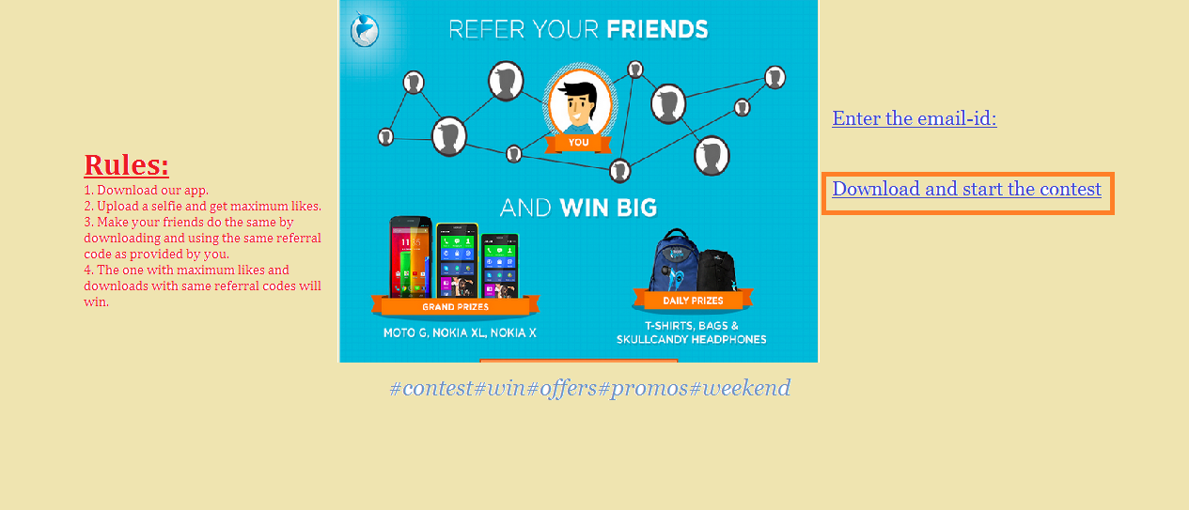

Part 4)-

Platforms used:

1. Facebook
2. Twitter
3. YouTube
4. Televison Advertisements
5. Radio Ads
6. Social Networking
7. Newspapers
8. Posters and Paints
9. Door to Door service
10. Contests and Prize wining

Part 5)-

1. Promotional emails
2. Ads on facebook, twitter, online newspapers, youtube etc
3. Create a page on facebook and inviting friends to like the page.
4. Ask the other pages and friends to share and promote the same.
5. Constant upload of the offers, discounts.
6. Contests held online with some exciting gifts and offers.
7. Start a blog.
8. Use press releases regularly.
9. Join relevant online community and contribute to the same.
10. Put videos of the product online.